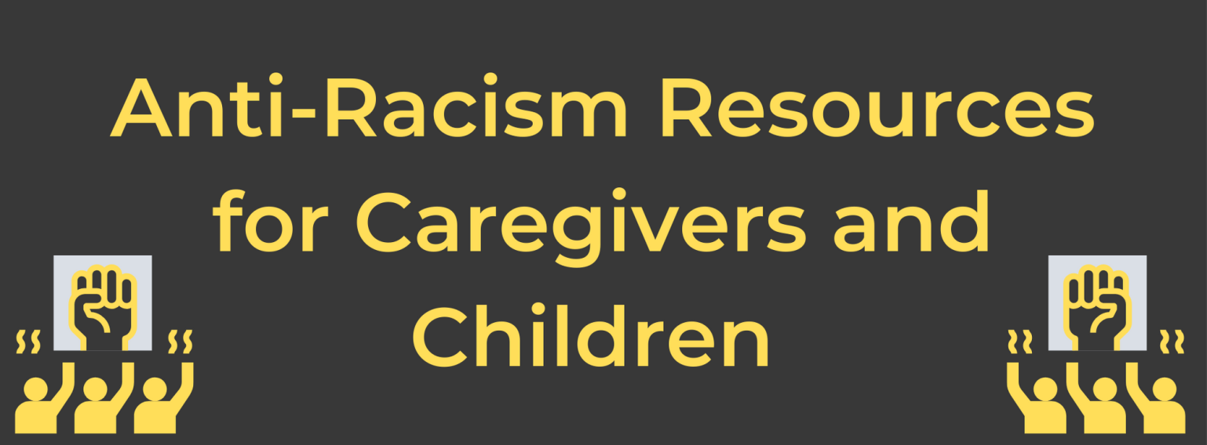

Talking to Children about Racism – Resources for Parents

Parents Leading on Racial Justice in their Communities
Articles, webinars, activity guides, children’s books and audio stories aimed at raising a generation of children who are thoughtful, informed, and brave about race. https://www.embracerace.org/

7-Minute listen/transcript of interview with author of “Raising White Kids,” Dr. Janice Harvey
Discussion on how white parents can talk to their kids about race.
'Raising White Kids' Author On How White Parents Can Talk About Race : NPR
YouTube presentation by the author, and free community guide to help facilitate conversations:
https://www.abingdonpress.com/surjresources

Talking to Kids about Race & Racism: A Conversation with Dr. Beverly Daniel Tatum
Presentation by the Spellman College Clinical Psychologist and author of “Why Are All the Black Kids Sitting Together in the Cafeteria?”
https://www.discoveryacton.org/event/virtual-event-talking-kids-about-race-and-racism-conversation-dr-beverly-daniel-tatum
“Is my skin brown because I drank chocolate milk?”
Dr. Tatum’s thoughts on this question that her son was asked. (13 minute Youtube clip)
https://www.youtube.com/watch?v=l_TFaS3KW6s

Raising Antiracist Children: A Better Future
Learning guide and 5 min. video interview with Dr. Ibram X Kendi’s about his book, Antiracist Baby.
Website also has a children’s book list: Raising Antiracist Children | Penguin Random House

CNN & Sesame Street’s Coming Together: Stand Up to Racism town hall (recommended by multiple resource lists). You can watch this with your children.
https://www.cnn.com/2020/06/06/app-news-section/cnn-sesame-street-race-town-hall-app-june-6-2020-app/index.html

Talking to Young Children about Racism
Video, printables, articles, parent-child conversations, book lists and links to other respected sites.
https://www.pbs.org/parents/talking-about-racism

Teaching Tolerance: How White Parents Should Talk to Their Young Kids about Race
Article highlighting research on the causes of racial bias, dispelling the myth that racism is a learned behavior in infants through 11 year olds.
Teaching tolerance: How white parents should talk to their kids about race. (slate.com)

Anti-Racist Resources for Parents from the Program for Early Parenting Support
Articles such as Your kids aren’t too young to talk about race, 100 race-conscious things you can say to your child, How to use books to talk about race, Resources for anti-racist parenting, Talking about race and culture differences with young children, Talking about racism and equality in age-appropriate ways (2-5 yrs). White-parent-specific articles for raising antiracist children, as well as lists of age-specific picture & adult books. https://www.peps.org/ParentResources/by-topic/anti-racist-resources-parents

Racism & Violence: Using Your Power as a Parent to Support Children Aged 2-5
Thoughts and guidelines from Zero to Three for talking about the complex issues of racism and equality in age-appropriate ways with ideas for answering difficult questions. The mission of Zero to Three is to ensure that all babies and toddlers have a strong start in life. Available in English & Spanish.
https://www.zerotothree.org/resources/1598-racism-and-violence-using-your-power-as-a-parent-to-support-children-aged-two-to-five

Five Ways to Reduce Racial Bias in Your Children
How children’s racial bias forms, and how parents can counteract the bias they may pick up on from society at large, backed up by scientific studies. Six additional recommended resources on this page.
https://greatergood.berkeley.edu/article/item/five_ways_to_reduce_racial_bias_in_your_children

Learning for Justice, Ages 2-Teen, a Project of the Southern Poverty Law Center
Free online book, Beyond the Golden Rule, divided into ages 2-5, elementary, and teen, as well as a section for parents to reflect on their own bias.
https://www.learningforjustice.org/sites/default/files/2017-07/Beyond_the_Golden_Rule_9.pdf

Countering Covid-19 Stigma and Racism Tips for Parents and Caregivers
The National Association of School Psychologists’ tips for caregivers during this already-stressful time. Available in Spanish and English.
https://www.nasponline.org/resources-and-publications/resources-and-podcasts/school-climate-safety-and-crisis/health-crisis-resources/countering-covid-19-(coronavirus)-stigma-and-racism-tips-for-parents-and-caregivers

Asian Americans, Racism and Anti-racism in the Covid Era
“Talking Race & Kids” series offers a transcript and video of a discussion with representatives of the Chinese Affirmative Action and Asian Pacific Policy & Planning Council, organizations.
https://www.embracerace.org/resources/asian-americans-racism-and-antiracism-in-the-covid-era

Dear Brown Girl: Proximity-to-Whiteness does not Make You White
Article written by the child of Indian immigrants about her experiences growing up, assimilating, confronting the effects of racism, and returning to her culture in an effort to give her biracial children what they will need to name, confront , and navigate racism.
https://www.embracerace.org/resources/dear-brown-girl-proximity-to-whiteness-does-not-make-you-white

Diverse Children’s Books Resources

https://diversebooks.org/

African American Children’s Book Project’s Best Picture Books of 2020
The AACBP believes that if you want to educate on social justice, you’ve got to teach Black History.
African American Children's Book Project's Best Picture Books of 2020 - The Brown Bookshelf

African American Literature Book Club Lists of Children’s Picture Books
Lists of books and movies reviewed by the oldest and largest online book store dedicated to African American and black literature from around the world. Learn More About picture books (aalbc.com)

28 Days Later
A yearly event takes place every February, highlighting the best picture, middle grade, and young adult novels that are written and illustrated by Black creators. Archives back to 2008 are available. Includes author’s background and review of each chosen books. 2021 Archives - The Brown Bookshelf

Latinxs in Kid Lit
Picture books and early readers which are by/for/about Latinx, with priority given to books by Latinx creators with Latinx content. Click on the book for a review. Reviewers have a wide variety of backgrounds and expertise including writers, librarians and teachers, connected to Puerto Rico, Brazil, Mexico, and Central/South America.
REVIEWED BOOKS: Picture Books & Early Readers | Latinxs in Kid Lit (latinosinkidlit.com)

Cynthia Leitch Smith Official Author Site & Home of Children’s & Young Adult Literature Resources
Many books with descriptions and diverse themes including interracial families, tribal stories, adoption, intergenerational families, immigrant families, all with appropriate age-ranges listed.
Interracial Children's Books: Picture Books - Cynthia Leitich Smith

Rise Up Against Racism
Nonprofit organization focused on implementing change through sustainable initiatives centered on families and education. Encourages antiracist learning and bringing the community together to actively dismantle racism. Includes information on their efforts to create Little Free Antiracist Libraries in communities.
R!SE UP AGAINST RACISM (ruar.org)

Local Resources for Diverse Books

Silver Unicorn Books, 12 Spruce Street, West Acton, 978-274-2757, info@silverunicornbooks.com
Frequent author visits (currently virtual, previously in person), storytimes, book launches. Purchase in store, online, contactless pickup & shipping; book group supplies. Antiracism & African American History reading list online under the “Recommendations” tab. Weekly newsletter. https://www.silverunicornbooks.com/

Valley Wild Books, 492 King Street, Littleton, 978-339-4523, valleywildbooks@gmail.com
New and used books, records, CDs, cassettes, DVDs and bluerays, comics, gift items. Donate used books or get store credit. In-store or contactless pickup available. https://www.valleywildbookstore.com/

The Concord Book Shop, 65 Main St., Concord Center, 978-369-2405, books@concordBookshop.com
Author visits, signed books, in-store, shipped, or curbside pickups. Libro.fm audio books partnership.
https://www.concordbookshop.com/

More Than Words, 56 Felton St., Waltham, 781-788-0035, esaurwald@mtwyouth.org https://mtwyouth.org/
Job training and youth development program for vulnerable teens and young adults in foster care, court involved, homeless or out of school. Six- to twelve-month core program gives participants the marketable and transferable job skills needed to succeed. Pop-up stores travel to special events. (During Covid, the store is operating online via the “shop” button with curbside pickup). Donation boxes onsite. Books, adult clothing, vinyl.

Library Resources for Anti-Racism Resources

Acton Memorial Library - Race, Racism & Resistance: E-books to Support Conversations:
http://library.booksite.com/7537/nl/?list=CNL1&group=EB243

Bedford Public Library – Black Lives Matter Picture Book List & Latinx and Hispanic Heritage Month Book List
https://www.bedfordlibrary.net/kids/booklists/

Sargent Memorial Library, Boxboro – Racial Equity Resource List with book Lists, movies, podcasts, TED Talks
https://boxlib.org/services/social-justice

Concord Public Library – Curated Picture Book Recommendations on Facebook:
Asian Pacific American Heritage Month Kids Books on Hoopla
It’s #Juneteenth – Learn More About the Holiday and History of Black Americans List
https://www.facebook.com/concordlibrary/photos/a.1648045105357679/1588160168012840/?type=3&theater
Books and Media about Racism resource list:
https://concordlibrary.org/resources/booklist/books-about-racism

Harvard Public Library – Learn about Black History Makers, explore cultural traditions and honor the evolution of black history in America (register as an individual or family):
https://harvardpubliclibrary.beanstack.org/reader365

Lincoln Public Library - Talking About Race with Kids Lincoln Children’s Librarians booklist:
https://www.lincolnpl.org/images/pdf/updated_race_booklist_61720.pdf
Social Justice and Black Voices for adults and teens booklist (Minuteman Library Network):
https://www.minlib.net/booklists/recommended-reads/social-justice-and-black-voices

Goodnow Library, Sudbury – Antiracism Resources for Children booklist:
https://goodnowlibrary.org/anti-racism-children/
Sudbury Cares (Community Anti-Racism Education Series) events: https://goodnowlibrary.org/sudbury-cares/

Background Resources for Parents

Equity vs. Equality & Other Racial Justice Definitions
In an effort to assist groups in their discussions on issues of racism, The Annie E. Casey Foundation has provided a list of definitions commonly misused, such as Race, Racial Justice, Internal Racism, Interpersonal Racism, Institutional Racism, Structural Racism, Systemic Racism, Racial Privilege and Racial Oppression. This nonprofit is devoted to developing a bright future for millions of children at risk of poor educational, economic, societal, and health outcomes.
https://www.aecf.org/blog/racial-justice-definitions/?gclid=Cj0KCQiApY6BBhCsARIsAOI_GjaqxOuu9DRYoAc9L5QR12nKL-q6cRe5Oqo-senEJ5fuezhTcxfNWDEaAtXCEALw_wcB

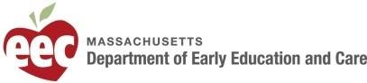
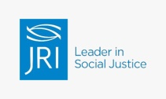
First Connections is funded by a Coordinated Family and Community Engagement grant awarded to Justice Resource Institute by the Mass. Department of Early Education and Care and by the generous support of Eastern Bank, Concord-Carlisle Community Chest, Acton Congregational Church, Trinitarian Congregational Church, Maynard Community Chest, Acton Boxborough United Way, the Nordblum Family Foundation and other community partners. We provide free support, early childhood and parent education, and resources to all families with children under age 9 living in Acton, Bedford, Boxborough, Carlisle, Concord, Harvard, Lincoln, Littleton, Maynard, Sudbury, Westford and Hanscom AFB. To view our direct services and programs, please go to: www.firstconnections. org

